**Special Features:**

It is a function for finding the most suitable earphone for the users. Users have to answer few questions to find the most suitable earphone.

Effect:

Step 1

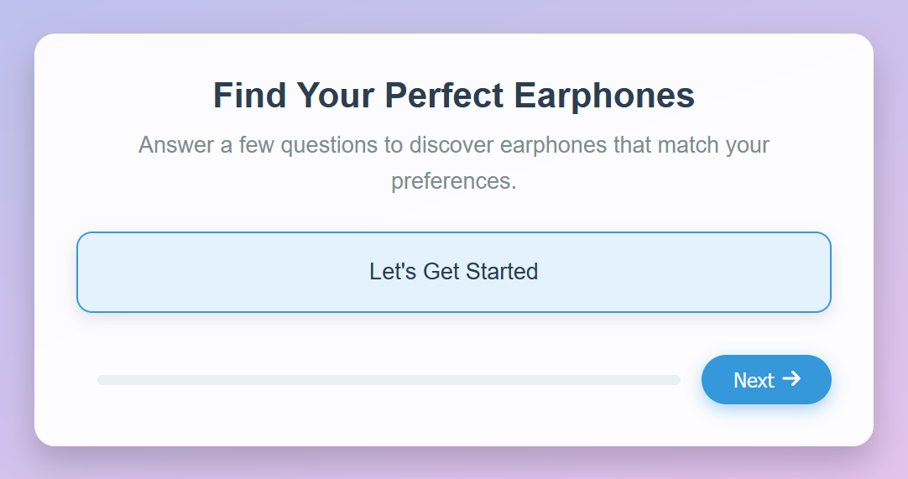

Step 2

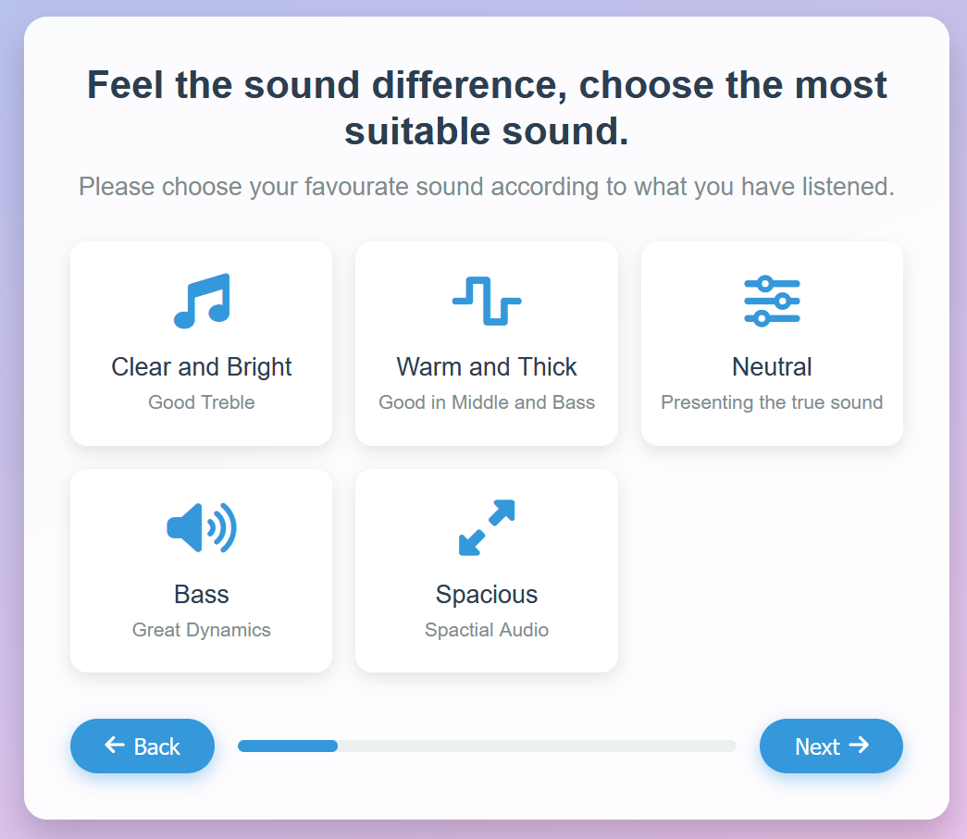

Step 3

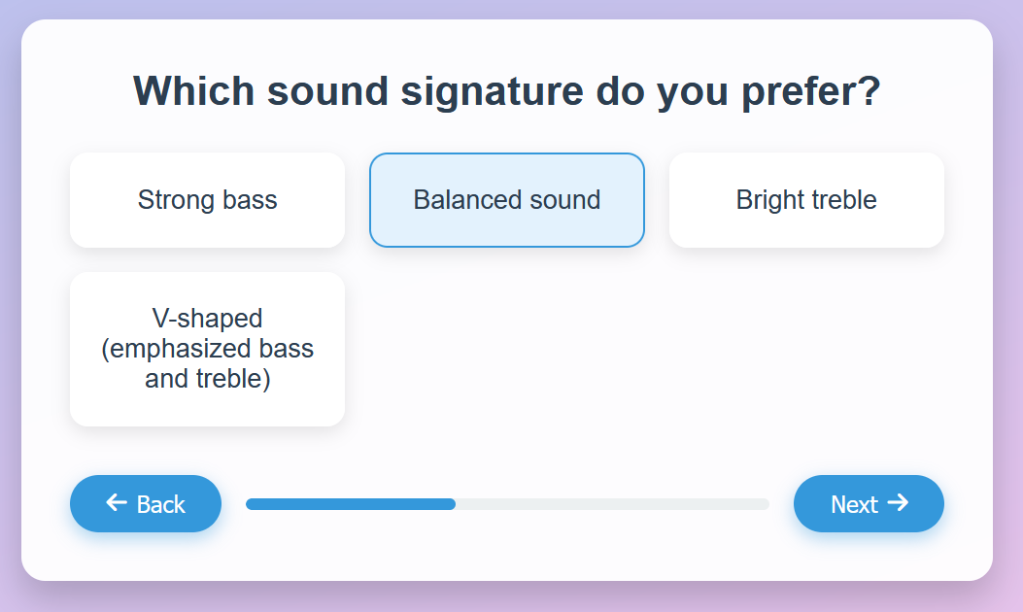

Step 4

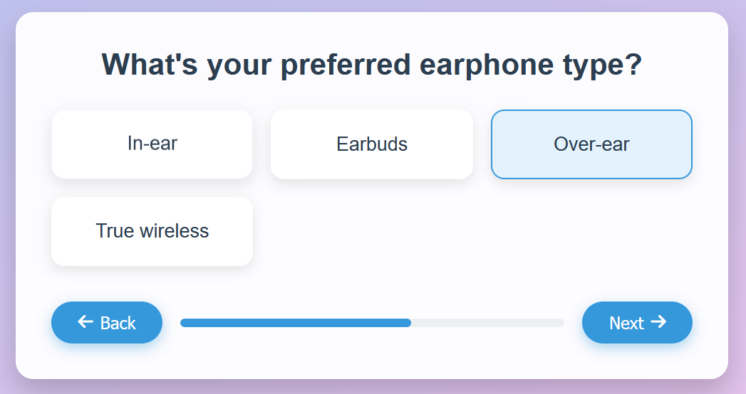

一張含有 文字, 螢幕擷取畫面, 字型, 數字 的圖片

AI 產生的內容可能不正確。Step 5

Step 6

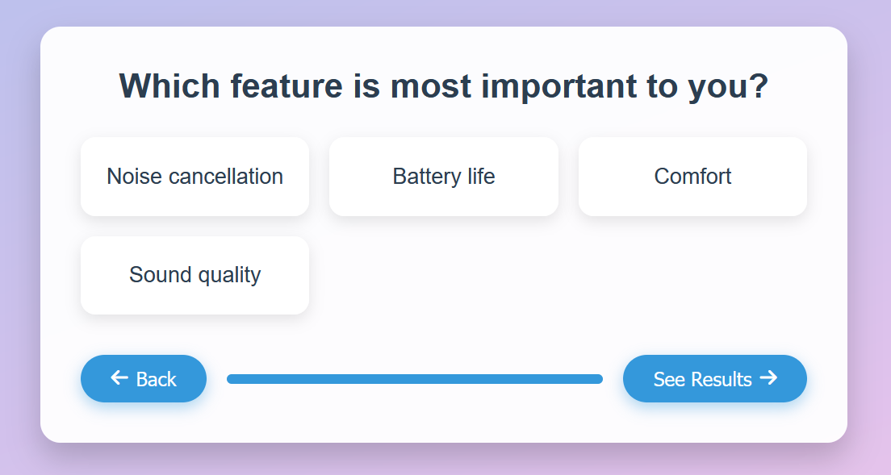

Step 7

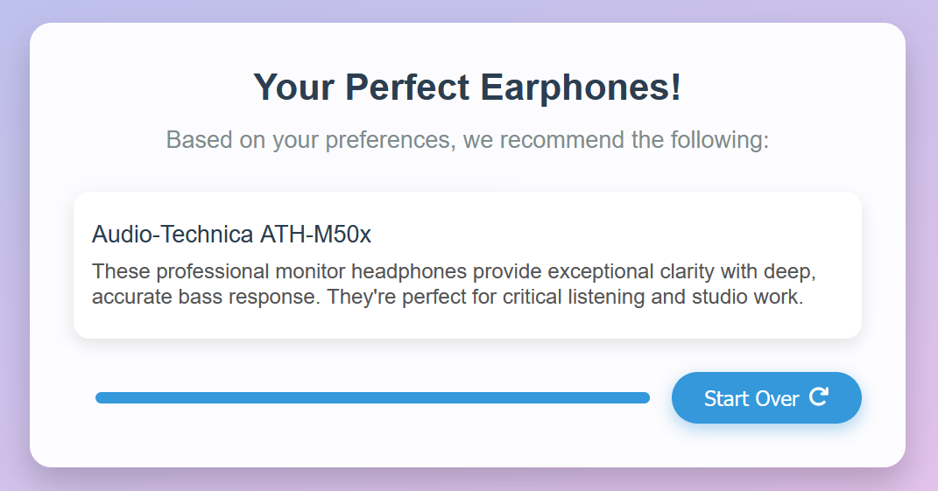

If there are no options chosen, the server will alert that after pressing the next button.



Code:

